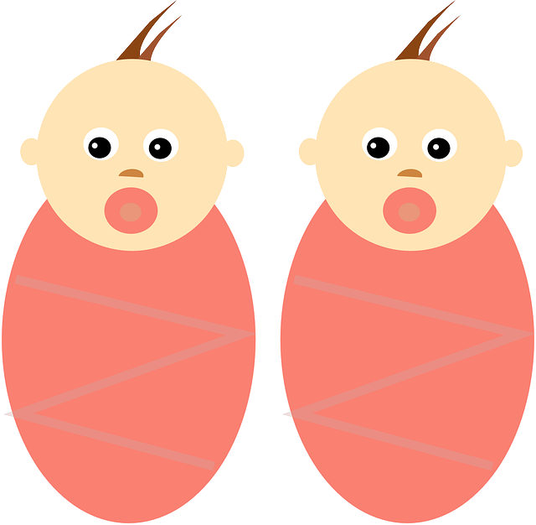
Edee and Eldora – born 23rd April 2019

